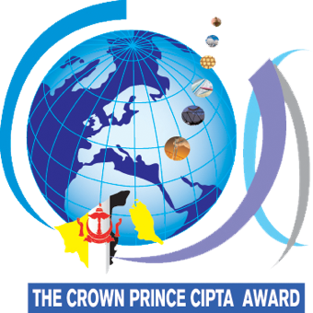
CIPTA 2023

THE COMPETITION FOR CREATIVE, INNOVATIVE PRODUCT AND TECHNOLOGICAL ADVANCEMENT

THEME: INNOVATIONS FOR SUSTAINABLE DEVELOPMENT GOALS

Entry form submission deadline: 9th January 2023.

Approval and Endorsement

Full Name: | (Authorising Person)
Role / Position:
Proposal Title:
Contact No: |  | (M) | (H) | (O)
Fax No:
Email:
Signature: |  |  | Official Stamp:

I declare that I am not representing any Institution / Organisation / School (Stamp is not required)

I declare that I am representing an Institution / Organisation / School / Company (Stamp is required)

*An official stamp is needed if you are representing an institution, organisation or a school.
*Please contact the Secretariat at cipta@utb.edu.bn for clarification, if necessary.

